Customization changes on Product lists page

* Menu should be as similar to that of what is suggested in home page. Currently Logo and Home button is overlapping in this page in chrome
* Reduce the space between product lists heading and to the product started below.



* Add the title above the line and bring them **Back to Men** to the bottom right as given in the picture above. Add the name and date columns as well
* Change **Back to Men** as **Back to Deals.** Whenever user clicks this it should redirect to the Deals page.
* Remove the **Prev/Next** options
* **3 Reviews** should be changed to **3 Comments**
* Remove the selection of the color and size section.
* When an user clicks on the similar products image that deal product lists page should be displayed here.

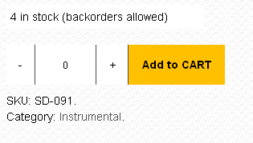

* Remove the red **SHOP NOW**
* Whenever the mouse is on **SHOP NOW** the button should be highlighted either by increasing the size or by changing a slight color.

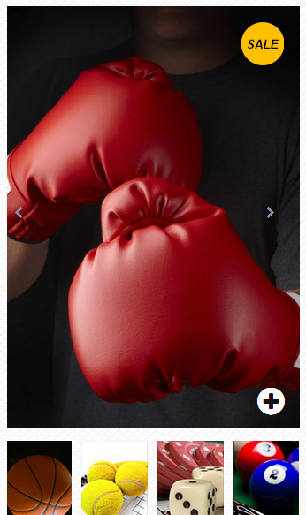

* Whenever the below images are clicked that image to be loaded in above big image.
* Right and left arrow on the image section is nice. If user clicks left arrow or right arrow the corresponding images which are shown in bottom of big image should be loaded.
* Whenever user clicks + button the same image should be zoomed.